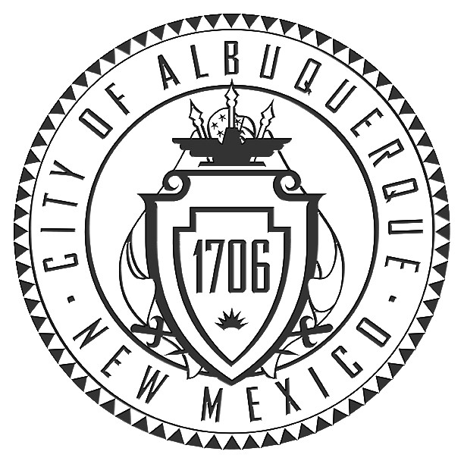
Office of the City Clerk

P.O. Box 1293
Albuquerque, NM 87103
Phone (505) 768-3030 Fax (505) 768-2845
www.cabq.gov/clerk

Amy B. Bailey, City Clerk

Campaign Financing Affidavit
The signed copy of this form must be received at the Office of the City Clerk on or before 12:00 p.m. (noon) on the following Campaign Financial Reporting deadlines:

First Statement: Friday, July 15, 2011
Second Statement: Friday, August 12, 2011
Third Statement: Friday, September 9, 2011
Fourth Statement: Friday, September 23, 2011
Fifth Statement: Friday, September 30, 2011
Sixth Statement: Monday, October 3, 2011
Seventh Statement: Tuesday, October 11, 2011
Eighth Statement: Friday, November 18, 2011

The form may by submitted by the following methods:

- Fax to (505) 768-2845;
- Email to abailey@cabq.gov;
- Delivered in-person to the Office of the City Clerk, City Hall, Room B2041; or

If this form is sent by fax or email, it must contain the signature of the candidate or treasurer. The original form must then be mailed or delivered within the next business day to the Office of the City Clerk at the above address.
State of New Mexico )
) ss.
County of Bernalillo )

I, , swear or affirm that the Financial Campaign Disclosure statement that I am submitting to the Office of the City Clerk on the day of , 2011 is true and correct to the best of my knowledge.

Signature of Candidate

Subscribed to before me this day of , 2011,
By
Notary Public
My Commission Expires:

